### 

### Semester Two Examination, 2023

### Question/Answer booklet

# 12 SPECIALIST MATHEMATICS

## Section One:

## Calculator-free

|  |
| --- |
|  |

Your Name

Your Teacher’s Name

## Time allowed for this section

Reading time before commencing work: five minutes

Working time: fifty minutes

## Materials required/recommended for this section

***To be provided by the supervisor***

This Question/Answer booklet

Formula sheet

***To be provided by the candidate***

Standard items: pens (blue/black preferred), pencils (including coloured), sharpener, correction fluid/tape, eraser, ruler, highlighters

Special items: nil

## Important note to candidates

No other items may be taken into the examination room. It is **your** responsibility to ensure that you do not have any unauthorised material. If you have any unauthorised material with you, hand it to the supervisor **before** reading any further.

|  |  |  |  |  |  |
| --- | --- | --- | --- | --- | --- |
| Question | Mark | Max | Question | Mark | Max |
| 1 |  | 9 | 5 |  | 7 |
| 2 |  | 7 | 6 |  | 8 |
| 3 |  | 8 |
| 4 |  | 9 |

**Structure of this paper**

|  |  |  |  |  |  |
| --- | --- | --- | --- | --- | --- |
| Section | Number of questions available | Number of questions to be answered | Working time (minutes) | Marks available | Percentage of examination |
| Section One:  Calculator-free | 6 | 6 | 50 | 48 | 33 |
| Section Two:  Calculator-assumed | 13 | 13 | 100 | 97 | 67 |
|  |  |  |  | **Total** | 100 |

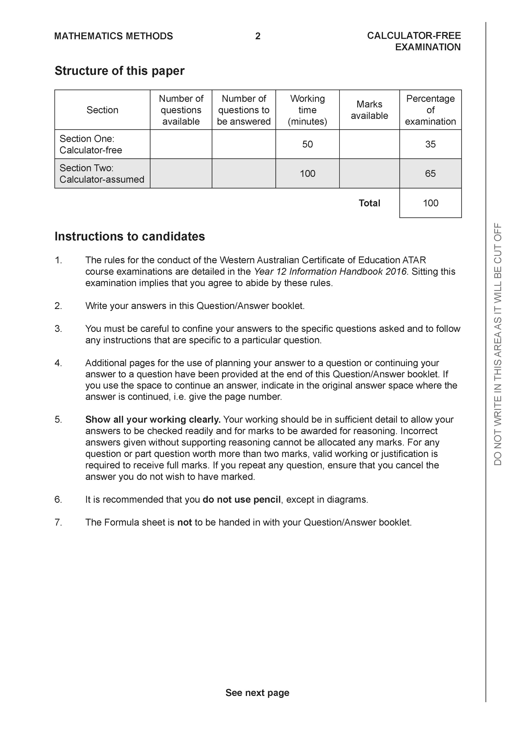

**Section One: Calculator-free (48 Marks)**

This section has **six (6)** questions. Answer **all** questions. Write your answers in the spaces provided.

Spare pages are included at the end of this booklet. They can be used for planning your responses and/or as additional space if required to continue an answer.

● Planning: If you use the spare pages for planning, indicate this clearly at the top of the page.

● Continuing an answer: If you need to use the space to continue an answer, indicate in the original answer space where the answer is continued, i.e. give the page number. Fill in the number of the question that you are continuing to answer at the top of the page.

Working time: 50 minutes.

**Question 1 (9 marks)**

Consider the functions  and .

1. Determine the natural domain and range of . (3 marks)
2. Does  exist over the natural domain of ? Explain. (3 marks)

1. State  and its natural domain. (3 marks)

**Question 2 (7 marks)**

Determine the following integrals.

1. . (3 marks)
2. . (4 marks)

**Question 3 (8 marks)**

1. The function  can be expressed in the form  where are constants.

Determine the values of . (4 marks)

1. Hence determine . (4 marks)

**Question 4 (9 marks)**

Consider a herd of 25 horses,  in an isolated habitat such that the growth rate after  years is given by .

1. By using separation of variables and partial fractions, derive  showing all working.

(5 marks)

Q4 continued

1. Determine the limiting value of the number of horses. (2 marks)
2. Set up an equation, but do not solve, that will allow the time to be calculated where the growth rate is a maximum. (2 marks)

**Question 5 (7 marks)**

A designer creates a heart-shaped pendant for Valentine’s Day shown on the right, using the function

<EFOFEX>

id:fxd{2ea7094e-ec83-4fe4-8952-d8890a69bc86}


FXData:

</EFOFEX>

For this equation becomes

$$2x^{2}-2xy+y^{2}-1=0$$

(a) Show that $\frac{dy}{dx}=\frac{2x-y}{x-y}$ for  (3 marks) (3 marks)

Q5 continued-

The jewellery plans to attached a small square shaped clasp to the pendant. One corner of the square will sit in the cusp on the curve at the point of contact. The situation is illustrated on the right below.

<EFOFEX>

id:fxd{b8923def-c0e2-4228-8fae-86914885a381}


FXData:

</EFOFEX>

(b) (i) Determine the coordinates of the point of contact.

(1 mark)

(ii) At the point of contact, will the gradient of the heart match that of the clasp?  
 Justify your answer. (3 marks)

**Question 6 (8 marks)**

Let $v=1+\sqrt{3}i$.

(a) Determine the three cube roots of $v$. (3 marks)

(b) Consider the polynomial $P\left(z\right)=z^{4}-8z^{3}+kz^{2}-46z+44$, where $k$ is a real constant.  
  
Given that $P\left(v\right)=0$, solve the equation $P\left(z\right)=0$. (5 marks)

**Working out space**

**Working out space**

**Working out space.**